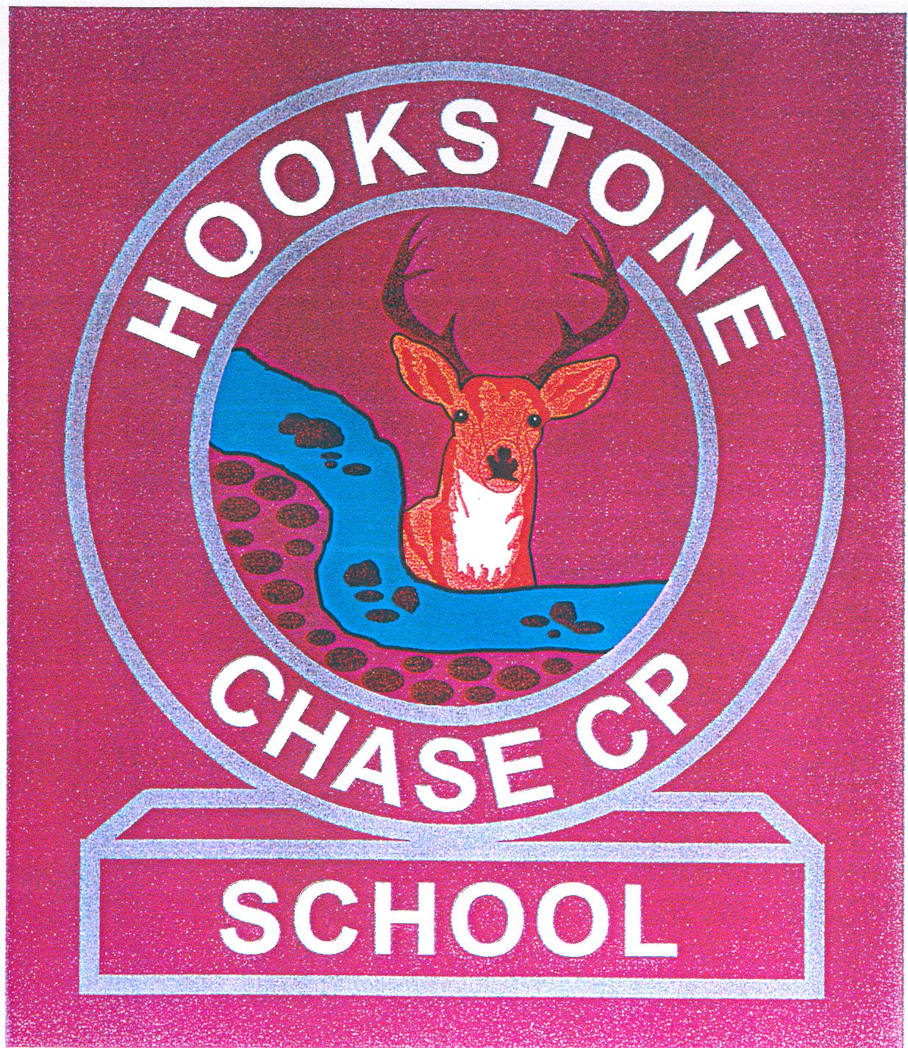
HOOKSTONE CHASE PRIMARY SCHOOL
Hookstone Chase, Harrogate, North Yorkshire HG2 7DJ
Telephone: 01423 886026
email: admin@hookstonechase.n-yorks.sch.uk

Headteacher Miss Ann Wheatcroft

9th May 2018

Dear Parents/Carers

We are writing to remind you that next week is the Test Week for all Year 6 children across the country.
The children will take tests in Reading, SPAG (Spelling, Punctuation and Grammar) and Maths. The time table for the week is:

Monday 14th May Spelling, Grammar and Punctuation Tests: Papers 1 & 2
Tuesday 15th May Reading Test
Wednesday 16th May Mathematics Tests: Paper 1: Arithmetic
Paper 2: Reasoning
Thursday 17th May Mathematics Test: Paper 3: Reasoning

To try to make the week as exciting and enjoyable as possible we have decided to run a “SATs Breakfast Club!” The children can arrive at school from 8:15am and enjoy: toast, cereal and juice. This is completely optional, but we feel it will provide a relaxed and positive start to the day, which will help the children perform well in the tests to follow.
It would also be really helpful if all the children are in school by 8:50am, at the latest, during the week, so we have plenty of time to prepare them for the tests each day. If there are any problems getting your child to school during this week, please contact school as soon as possible so we can help. It is really important that all the children attend school during test week.

The children have worked extremely hard to prepare for these tests and we are sure that they will do their very best. It would be really helpful if they get plenty of rest over the weekend and go to bed at a sensible time the night before each test.
Many thanks for your cooperation.

Yours sincerely

Mr Parker and Mrs Hazell
Y6 Class Teachers

