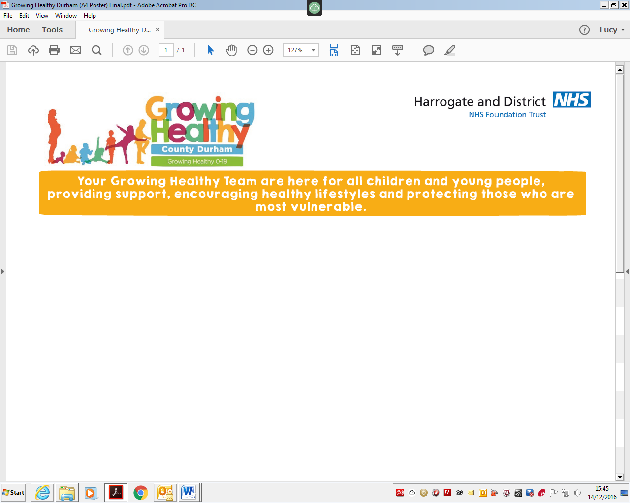

[childhood.immunisations@hdft.nhs.uk](mailto:childhood.immunisations@hdft.nhs.uk)

01423 542360

Hookstone Chase Primary School

September 2019

Dear Parent/Guardian,

***Protecting Children Against Influenza (Flu) and Complications***

The **nasal influenza vaccination** is being offered to **all children in Reception-Year 6**. Our team is scheduled to visit Hookstone Chase Primary School this Autumn as part of this programme. If you would like your child to receive this immunisation, please ensure your consent form has been submitted no later than **15/11/2019** – if you submit your consent form after this date your child may be missed at school.

Please see below for details of how to consent for your child and answers to common questions about the influenza vaccination programme.

***How do I give my consent?***

1. Go to [www.hdft.nhs.uk/flu-consent](http://www.hdft.nhs.uk/flu-consent)
2. Click on the **link in the grey box** which says “Click here for the online consent form.”
3. Enter the School Code **143287** and click **“Find School”**.
4. **Complete the form** with your child’s information and parent/guardian contact information*.
5. Click the **green “Submit” button**.

*If you provide a **valid email address** you will receive an automatic email confirmation to say your form has been submitted. We will also email you to let you know that your child has been vaccinated in school. If your child has specific medical requirements, one of our nurses may need to get in touch before we are due to visit school. We never pass on your contact information to third parties.

***Why is the influenza vaccine being offered?***

This vaccination programme is in place to help protect your child against influenza (flu) and stop the spread of the virus within schools, families and the wider community. Influenza is an unpleasant illness that can lead to school absences and sometimes causes serious complications requiring hospitalisation. Vaccinating your child doesn’t just project them – by helping to stop the spread of influenza this winter they will also be protecting vulnerable friends and family of all ages.

***How is the influenza vaccine administered?***

Unlike most vaccinations, the nasal influenza vaccine is a quick and simple spray up the nose. There are a small number of children for whom the nasal vaccine is not appropriate. In these cases we offer an intramuscular injection as an alternative. Please check the link below for more information.

***Does the nasal influenza vaccine contain pork gelatine?***

***Can my child have the injection instead?***

Yes, the nasal influenza vaccine contains trace amounts of porcine gelatine. If the vaccine is refused due to this content, only children who are at **high risk** from influenza due to an underlying medical condition will be offered an injected vaccine as an alternative.

***Where can I find out more?***

Please visit <https://www.nhs.uk/conditions/vaccinations/child-flu-vaccine> for more information about the childhood influenza vaccination programme.

You can contact the Childhood Immunisations team on [childhood.immunisations@hdft.nhs.uk](mailto:childhood.immunisations@hdft.nhs.uk) or 01423 542360. We are a small team, but we endeavor to respond to all queries within one working day.

Yours sincerely,



**Lois Alderson**

**Clinical Lead for Childhood Immunisations in North Yorkshire and City of York**



**A NATIONAL HEALTH SERVICE FOUNDATION TRUST Chairman – Angela Schofield Chief Executive – Steve Russell**