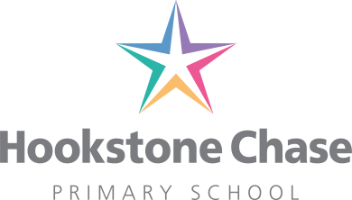
20th January 2020

To the Parent/Carer of Holly, Willow, Pine and Hawthorn Year 1 & Year 2 children

Dear Parents

As part of our ‘History’ and ‘Outdoor Learning’ curriculum and our programme of enrichment activities, we have arranged a very special workshop with Alfresco Learning.

Visit from Alfresco Learning: Thursday 30th January 2020
The workshop will be interactive and exciting and will give the children opportunities to enhance their understanding of their current topic, ‘Castles’ using the outdoor area! The workshop will develop the children’s teamwork and communication skills and allow them to experience the use of tools. They will be exploring different castle structures and go through the design process to design their own castle using natural materials. Also the workshop will allow the children to secure their understanding of 2D and 3D shapes whilst enforcing their knowledge about castles. The session is delivered by two ex-teachers and will be closely supervised.

As the children will be outdoors whatever the weather, we would ask that they come to school in their normal school uniform but bring the following items to change into:-
- One pair of old tracksuit bottoms and/or waterproof trousers in a named carrier bag
- A waterproof coat/rain coat or waterproof suit
- Wellies
- Spare gloves
- Hat and gloves

We are asking for a voluntary contribution of £3.30 towards the cost of the workshops and would encourage you to pay online through ParentPay at www.parentpay.com. If sending cash, please enclose in an envelope marked with your child’s name and class. Also please could you complete and return the Alfresco Learning photo permission form attached to this letter. Thank you

Yours sincerely

Miss Chamberlain, Mrs Fitzgibbon, Miss Smith and Mr Walsh
Holly, Willow, Pine and Hawthorn (Y2s) Classes

