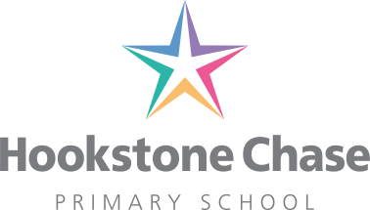

18th June 2019

To Parents/carers of pupils in Reception and Year 1

Dear Parents/Carers

Rainbow Factory Performance of ‘Jack and the Beanstalk’ : Monday, 1st July 2019

On Monday 1st July, Rainbow Factory will be visiting school to perform the traditional tale ‘Jack and the Beanstalk’ to pupils in Reception and Year 1.
The children will join Jack and his mum for a fun packed adventure through this fairytale favourite. This interactive performance will delight and excite the children as they get physically involved - climbing the beanstalk and helping Jack tiptoe into the giant’s castle in search of fortune and glory!
We are requesting a voluntary donation of £2.80 per pupil towards this performance. ‘Jack and the Beanstalk’ is set up on ParentPay at www.parentpay.com If paying by cheque please make payable to ‘Hookstone Chase Primary School.
I am sure the children will enjoy this entertaining performance.

Yours sincerely

Vivien Watson
Headteacher
…………………………………………………………………………………………………………………………………………

To: Miss Watson

Performance of ‘Jack and the Beanstalk’ : Monday 1st July 2019

Child’s name: ………………………………………………………………….. Class: ……………………………………

I enclose £2.80 / I have paid on line via ParentPay

