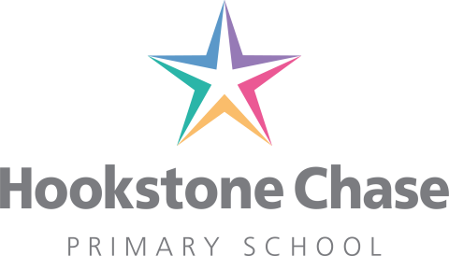

22nd July 2021

Dear Parents and Carers,
Relationships and Sex Education (RSE) consultation letter to parents

I am writing to invite you to share your thoughts and opinions with us regarding the proposed changes concerning our RSE curriculum.
At Hookstone Chase, we value your opinions and input regarding the education of your children and would like to ensure you are consulted in any policy change regarding this part of the curriculum. Parents should have every opportunity to understand the purpose and content of relationships education and RSE, and we would like to develop a cooperative relationship with you.
The new RSE policy is attached to this email. The questionnaire link is:
We would like to invite you to share any concerns or thoughts regarding this proposed change in policy.
You will also be able to access a copy of our RSE policy on the school website or via the the school office for your own reference.
We invite you to complete an online survey which will be sent to you via the email address you have provided to school and want you to know that all your responses will be treated confidentially.
This is an important opportunity to discuss how RSE contributes to wider support in terms of pupil wellbeing and keeping children safe, and to recognise that a range of approaches may be needed.
Thank you for taking the time to read this letter and the attached policy; I look forward to hearing your input. If you have any additional queries, please feel free to contact me via admin@hookstonechase.n-yorks.sch.uk or 01423 886026.
Yours sincerely,
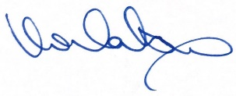
Miss Watson

