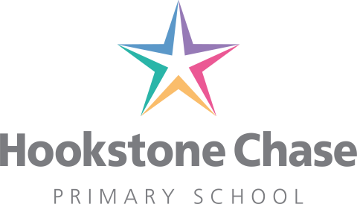

Dear Parents and Carers,

Covid-19 Testing

I am writing to all parents and carers to explain what must happen if your child or anyone in your house has any of the symptoms of Covid-19. As this is not typically flu season, we would expect that any symptoms would likely be the virus and so we will ask you to take the necessary precautions to keep safe and reduce the risk of transmission.

The main symptoms of corona virus are:

- High temperature – this means you feel hot to touch on your chest or back (you do not need to measure your temperature)
- New continuous cough – this means coughing a lot for more than an hour, or 3 or more coughing episodes in 24 hours (if you usually have a cough, it may be worse than usual)
- Loss or change to your sense of smell or taste – this means you’ve noticed you cannot smell or taste anything, or smell or taste different to normal.

Most people with coronavirus have at least one of these symptoms.

If your child or any member of your household have any of these symptoms you should not send your child to school. The person with symptoms should remain self-isolated indoors for a period of seven days. Anyone who lives in the same household (even if they do not have symptoms) must self-isolate for 14 days from when the first person in your home started having symptoms.

You should use the 111 Online Corona service and they will be able to direct you to a test. If the test comes back negative your child may return to school if they feel well enough to do so.

If you are self-isolating:
- do not go to work, school or public places – work from home if you can
- do not go on public transport or use taxis
- do not go out to get food and medicine – order it online or by phone, or ask someone to bring it to your home
- do not have visitors in your home, including friends and family – except for people providing essential care
- do not go out to exercise – exercise at home or in your garden, if you have one

In order to safeguard our school community we will expect all parents to ensure that children remain socially distanced outside of school and we may ask that your child takes a period of time to self-isolate if we suspect they have not been. This is to ensure the safety of our children and staff. The more we adhere to the government guidelines the quicker we will beat this virus.

You may want to tell people you have been in close contact with if your child or anyone in your household has any symptoms.

We strongly advise that anyone collecting or dropping off children come alone and remain socially distanced from other people at drop off and pick up points. It is not appropriate for people who are extremely vulnerable to be entering the school grounds and we welcome discussions to support you with this if you need our help.

If someone in your child’s bubble present with symptoms, we will contact you to let you know. You can then follow the advice on the NHS helpline.

https://www.nhs.uk/conditions/coronavirus-covid-19/

At times we may need to make the difficult decision to close bubbles due to someone within in the bubble presenting with symptoms. We will try to avoid this but if anyone tests positive the bubble will have to close and any connected families will be expected to self-isolate for a period of 14 days.

You may have heard the government talk about catch up programmes and blended learning (online lessons.) Our focus so far has been on making the school safe for our children attending and providing work and care (including food packages) for families at home. We are in discussion about how we can now provide further support as we have been informed that school will not reopen before September for many of our children. We will be contacting you next week with these exciting plans.

We are grateful for your ongoing support in this matter.

Yours sincerely,

Miss Watson

